Design Thinking Project Report on

**DINE IN AND RIDE OUT**

Submitted to

The Department of Computer Science and Engineering (Data Science)

Bachelor of Technology

in

Computer Science and Engineering (Data Science)

(2022 – 2026)

D.HARSHAVARDHAN 22R11A6796

D.SHANMUKH NAYAN 22R11A6797

D.UTTAM KUMAR 22R15A6798

Under the Guidance of

Dr.A.Venkata Ramana, Asst.prof

 Mrs. N.Madhavi, Asst.prof

Department of Computer Science and Engineering (Data Science)

Accredited by NBA

**Geethanjali College of Engineering and Technology (UGC Autonomous)**

(Affiliated to J.N.T.U.H, Approved by AICTE, New Delhi)

Cheeryal (V), Keesara (M), Medchal.Dist.-501301.

**ABSTRACT**

In modern day of technology cab rides and food deliveries became two distinct services that offer unique benefits to customers but doesn’t to drivers. Cab rides provide a means of transportation for people to get from one place to another, while food delivery allows people to order meals from restaurants and have them delivered to their location. However, by integrating cab rides and food delivery on a single platform can offer additional convenience and benefits to the cab drivers and customers. For this reason, we propose a sophisticated platform were integrating cab rides and food delivery on a single platform. By integrating these two services, drivers and customers can save time and effort while enjoying a hassle-free experience. This platform can utilize technology to connect customers with nearby drivers and restaurants in real-time. Customers can use a mobile to place orders for food delivery, and this platform can assign drivers who are available to deliver the food while simultaneously offering a cab ride to the customer. To ensure customer satisfaction and safety, the platform can implement a system of quality control measures, including driver and restaurant ratings, customer feedback, and regular inspections of the vehicles used for transportation. By integrating cab rides and food delivery on a single platform can offer additional convenience and benefits to drivers as a extra income. This platform could coordinate the delivery of food while simultaneously offering a cab ride to the customer, saving time and effort for the customer and drivers. Additionally, integrating cab rides and food delivery on a single platform can offer benefits to businesses as well. Restaurants can benefit from increased exposure and access to a larger customer base, while transportation companies can expand their services and generate additional revenue. Overall, integrating cab rides and food delivery on a single platform can provide convenience and benefits to customers while creating new business opportunities and new sectors. By carefully addressing potential challenges and problems, then this platform can be a successful and profitable venture.

**INDEX**

**Abstract** I

**1. Introduction** 1

1.1 Object 1

1.2 Scope 1

1.3 Existing System 2

1.4 Proposed System 3

**2. System Analysis** 4

2.1 Functional requirement specification 4

2.2 Performance requirements 4

2.3 Software requirements 5

2.4 Hardware requirements 5

**3. System design** 6

3.1 Architectural design 6

3.2 Modules 7

**4. System implementation** 8

4.1 Algorithms 8

**5. Output Screens** 15

**6. Future scope** 23

**7. Conclusion** 24

**8. References** 25

**List of Figures**

**S.no Fig no Title of Figure Page no**

1. 3.1Design or View of project 6
2. 5.1 Home page of Dine in and ride out page 15
3. 5.2 Service Selection page 15
4. 5.3 Cab Login and Sign-up pages 16
5. 5.4 Pickup and Dropoff locations selecting page 17
6. 5.5 Cab type selection page 17
7. 5.6 Cab Confirmation page 18
8. 5.7 Food Login and Sign-up pages 18
9. 5.8 Dropoff location for food delivery 19
10. 5.9 Restaurants selection page 20
11. 5.10 Food Confirmation page 20
12. 5.11 Driver Login page 21
13. 5.12 Map view if there is possibility for

food and cab 21

1. 5.13 Map view if there is not possibility for

food and cab 22

* + - 1. **INTRODUCTION**

Integrating cab rides and food delivery on a single platform presents a compelling proposition that can revolutionize the way customers experience transportation and dining. In the modern age of technology, where convenience plays a pivotal role in shaping consumer preferences, this sophisticated platform aims to seamlessly connect customers with nearby drivers and restaurants in real-time. By offering the ability to order meals from restaurants and simultaneously arrange cab rides, this integrated service promises time and effort savings for both customers and drivers, while opening up new business opportunities for restaurants and transportation companies.

**1.1 Objectives**

To create a user-friendly website that allows customers to effortlessly order food and request cab rides with minimal steps and to ensure efficient coordination between food delivery and cab ride services, providing customers with a smooth, integrated experience.

**1.2 Scope**

The scope of the Dine IN & Ride OUT platform is to offer a unique and integrated service that combines food delivery and cab rides in a single platform. The platform operates as a single service provider for customers, allowing them to book cabs and order food from various locations.

This platform provides the food delivery and cab rides as one service at a time and by a one service provider only. This platform runs differently for booking cabs and ordering foods from customers whereas provides as one service to give by the driver.

The customers can book their cabs, order foods at different places or locations but according to the locations provided from the customers or ordered places then there is a possibility to accept food orders and cab rides. Integrating these two services in a one platform increases Revenue for Drivers cab drivers can capitalize on additional income opportunities by accepting food delivery requests simultaneously providing cab rides and also during periods of low demand for cab rides, Drivers can optimize their working hours and reduce downtime by accepting both cab and food delivery requests, leading to better resource utilization, The platform offers both food delivery and cab ride services, making it convenient for customers to access both services through one app, Customers can book cabs and order food from different locations, providing flexibility in their choices.

**1.3 Existing Systems**

While the independent cab service, food delivery service provided separate services with respect to their usage they lacked integration to offer cab rides and food deliveries together on a single platform which gives extra benefit to drivers and also customers had to use different apps for these services, leading to potential inconveniences and a fragmented user experience.

* The following are the drawbacks of the current existing systems:
* **Time-Consuming Process:** Using separate apps or platforms for cab rides and food delivery meant that customers had to spend more time navigating different interfaces, placing orders, and managing payments.
* **Limited Options for Drivers:** Drivers who were solely providing cab rides might face idle periods during low demand, leading to potential income loss. Integrating food delivery could have offered additional income opportunities during these periods.
* **Missed Synergy:** By not integrating the two services, there was a missed opportunity to provide a seamless experience where customers could easily combine transportation and dining needs on a single platform.
* **Market Fragmentation:** The existence of numerous independent cab ride and food delivery platforms could lead to market fragmentation, making it challenging for customers to identify the most efficient and reliable services.
* **Duplication of Efforts:** Businesses offering both cab rides and food delivery services separately might have duplicated efforts in terms of maintaining separate driver fleets, customer support teams, and backend operations.

Overall, the drawbacks of the existing manual system highlighted the need for a sophisticated

platform that seamlessly integrated cab rides and food delivery, offering convenience to customers, additional income for drivers, and potential business advantages for service providers. The proposed integrated platform aimed to overcome these limitations and create a more efficient and user-friendly experience for all.

**1.4 Proposed System**

The proposed system is an innovative and sophisticated platform that aims to integrate cab rides and food delivery services on a single platform, providing a seamless and convenient experience for customers, drivers, and businesses. The both services of food delivery, cab rides are independent to each other means it works irrespective no connectivity to each other but the food delivery and cab ride is done through the one driver which gives numerous advantages for both customers, drivers and also provide of new business idea.

* Here are the key features and benefits of the proposed system:
* **Integrated Service Platform:** The proposed system combines cab ride and food delivery services into one user-friendly application
* **Simultaneous Service Provision:** While customers place separate orders for food delivery and cab rides, the platform can assign drivers who are available to handle both requests simultaneously, maximizing their earning potential.
* **Additional Income Opportunities for Drivers:** Cab drivers can accept food delivery orders during periods of low demand for cab rides, augmenting their income and reducing idle time.
* **Diversified Revenue Streams for Businesses:** Transportation companies can expand their services and generate additional revenue by venturing into the food delivery market, diversifying their income sources.

The proposed system aims to bridge the gap between cab rides and food delivery, providing a comprehensive solution that benefits customers, drivers, and businesses alike. By carefully addressing potential challenges and continuously improving its offerings, the integrated platform has the potential to become a successful and profitable venture, revolutionizing the way people experience transportation and dining services.

* + - 1. **SYSTEM ANALYSIS**

System analysis for the Dine IN & Ride OUT platform involves a comprehensive review of the project goals, breaking down the system into various modules, and specifying functional requirements and performance criteria.

**2.1 Functional Requirement Specification**

The Dine IN & Ride OUT platform has been identified to consist of the following modules:

* User/Customer Module
  + - Users can register and create accounts on the platform.
    - Customers can search for nearby restaurants and available cab rides.
    - Customers can place food delivery orders and book cab rides.
* Driver Module:
  + - Drivers can register and create profiles on the platform.
    - Drivers can accept food delivery orders and cab ride requests.
    - Drivers can accept cab ride requests only.
    - Drivers can view the pickup location for both food delivery and cab rides.
* Client Side/Admin Module:
  + - The platform will have an admin who can manage user accounts, verify registrations, and handle system settings.
    - The administrator can oversee driver and restaurant profiles and maintain overall platform security.

**2.2 Performance Requirements**

Performance requirements for the Dine IN & Ride OUT platform are crucial for ensuring a smooth and efficient user experience. Key performance criteria include:

* **Real-time Connectivity:** The platform should provide real-time connectivity between customers, drivers, and restaurants to enable quick service and accurate tracking.
* **Probability:** The platform should make every cab ride and food delivery possible if and only if there is passage of same route to deliver food and give a cab service.
* **Scalability:** The system should be scalable to handle a growing user base and increasing demands for both cab rides and food deliveries.
* **Reliability:** The platform must be reliable, with minimal downtime or service disruptions, to maintain trust and customer satisfaction.

**2.3 Software Requirements**

* The software requirements are:
* Operating System: Microsoft Windows XP.
* Front-End: HTML, CSS, and JavaScript.
* Back-End: JavaScript.
* Database Management System MySQL.
* Web-Server: Node JS.
* Framework: Express.

**2.4 Hardware Requirements**

* Processor: Intel P-IV based system
* RAM: Min. 512 MB

1. **SYSTEM DESIGN**

System design for the Dine IN & Ride OUT platform involves the detailed specification of the architecture, components, modules, data flow, and interactions between different parts of the system. It focuses on converting the requirements into a well-structured and efficient system that meets the users' needs.

**3.1 Architectural Design**

The architectural design of the Dine IN & Ride OUT platform encompasses various components that work together to deliver a seamless user experience.

The system architecture can be represented as follows:

The user/customer, driver, and restaurant are the main actors in the system. The front-end components, developed using HTML, CSS, and JavaScript, provide a user-friendly interface for users to interact with the platform. The back-end components, built using Node.js, Express, and MySQL, handle the data processing, business logic, and communication with the database.

Po Ptst Post

***Cab rides***

***Customer’s Services***

***Cab Booking***

***Driver***

***Server***

***or***

***Cab rides with Food Delivery***

***Food Ordering***

***Data***

***base***

Fig 3.1 Design or View of project.

**3.2 Modules**

* **User/Customer Module:**

**1.Cab Services:**

* User Login: Customers can login if they already have an account.
* User Sign-Up: Customers can register and create accounts on the platform if they are new.
* Cab Locations Specifying: Customers can book cab rides to their desired destinations from their locations.
* Cab Booking: Customers prefer their type of cab to ride according to the price.
* Cab Confirmation: Customers can know that their cab gets booked.

**2.Food Services:**

* User Login: Customers can login if they already have an account.
* User Sign-Up: Customers can register and create accounts on the platform if they are new.
* Restaurants Selection: Customers can browse their needed restaurants, type if Food.
* Food Order: Customers can place their food to get deliver.
* Food Confirmation: Customers can know that their food order is confirmed.
* **Driver Module:**
  + Driver Login: Drivers can login with their identity or service number.
  + Service Management: Drivers receive and manage food delivery orders and cab ride requests if there is a possibility with locations or else go with the cab ride.

The system design ensures that each module works cohesively, facilitating a smooth user experience and efficient service delivery for food delivery and cab ride requests. The architecture and modules form the foundation for the development and implementation of the Dine IN & Ride OUT platform. It focuses on converting the requirements into a well-structured and efficient system that meets the users' needs.

1. **SYSTEM IMPLEMENTATION**

The implementation stage of any project is a true display of the defining moments that make a project a success or a failure. The implementation stage is defined as the system or system modifications being installed and made operational in a production environment. The phase is initiated after the system has been tested and accepted by the user. This phase continues until the system is operating in production in accordance with the defined user requirements.

**4.1 Algorithms**

**Algorithm main page**

**{**

Enter Portal number of the website in the web browser (http://localhost:3000)

If (Client)

{

Goto Client ();

}

Else if (User)

{

Goto User ();

}

Else

{

The rest of the viewers have the visibility of only the following Pages to more about the site

About

Contact

Details

}

}

**// end of main page….**

**Algorithm Customers page**

{

// Select Services CAB SERVICES (OR) FOOD SERVICES

If (cab services)

{

Redirect to Cab Login page;

}

**Algorithm Cab**

{

**Algorithm Cab Login Page**

{

If (Already registered then login)

{

1. Enter Username and password;
2. Click Login

}

Else

{

click Register to get registered.

}

}

**// Redirecting to Sign-up page**

**Algorithm Cab Sign-up Page**

{

If (Sign-Up)

{

Fill registration form and submit;

After successful Signup page will redirect to next page;

}

}

**// Redirecting to Cab Map**

**Algorithm Cab Map Page**

{

Enter Pick-up Location in Search Bar;

Enter Drop-Off Location in Search Bar;

// According to the pick-up and drop-off the distance and route will be calculate and shown;

If (Button Submit Clicked)

{

The Pick-up Location, Drop-Off Location are storing in Database Using Post method by using node js as server side;

&&

Distance is Redirected to next Page;

}

Else // (Clear Button)

{

The Pick-up Location, Drop-Off Location gets Clear;

}

}

**// Redirecting to Cab Booking**

**// According to the pick-up and drop-off the Distance is Displayed**

**Algorithm Cab Booking**

{

If (Submit Button)

{

Type of Cab is Selected

Bike,

Auto,

Car etc.……...

}

Calculates the Price according to Distance;

If (Submit)

{

Cab Confirmed;

}

Else

{

Redirect to Cab map page;

}

}

**// Cab Confirmation is Done;**

}

Else (Food Services)

{

Redirect to Food Login Page;

}

**Algorithm Food**

{

**Algorithm Food Login Page**

{

If (Already registered then login)

{

1. Enter Username and password;
2. Click Login

}

Else

{

click Register to get registered.

}

}

**// Redirecting to Sign-up page**

**Algorithm Food Sign-up Page**

{

If (Sign-Up)

{

Fill registration form and submit;

After successful Signup page will redirect to next page;

}

}

**// Redirecting to Food Drop OFF location**

**Algorithm Food Drop-Off:**

{

Enter Drop-Off Location in Search Bar;

If (Button Submit Clicked)

{

The Drop-Off Location are storing in Database for food delivery Using Post method by using node js as server side;

}

**// Redirects to Restaurants Page**

Else (Clear)

{

Clear the Locations;

}

}

**Algorithm Restaurants**

{

According to select option a type of food restaurants is to be select

If (Select Option)

{

Vegetarian

Non- vegetarian

Tiffin

Pizzas

}

// Then display of the Restaurants according to the type of food;

If (Submit Clicked)

{

The Restaurants Locations are storing in Database Using Post method by using node js as server side;

}

}

**Algorithm Type of Food**

{

//According to type of food the Food Items display

If (Submit Button)

{

Food Order gets Confirms;

}

}

**// Food Order Confirmation is Done;**

}

**Algorithm Client**

{

**Algorithm Client Login**

{

If (Account Login)

{

1. Enter Username, password, service;
2. Click Login

}

}

**Algorithm Client Fetch Routes**

{

If (Fetch Routes) // Clicked

{

The Pick-up, Drop-Off Locations for Cab && The Pick-up, Drop-Off Locations for Food gets Displayed in map and routes Visible;

If (Routes >2 && Route Possible to Drive)

{

**Client confirms the Food Order and Cab Ride;**

}

Else

{

**Continue with only Cab Services;**

}

}

}

**5. OUTPUT SCREENS**

Output Screens of various functionalities in our application are shown over here along with the description.

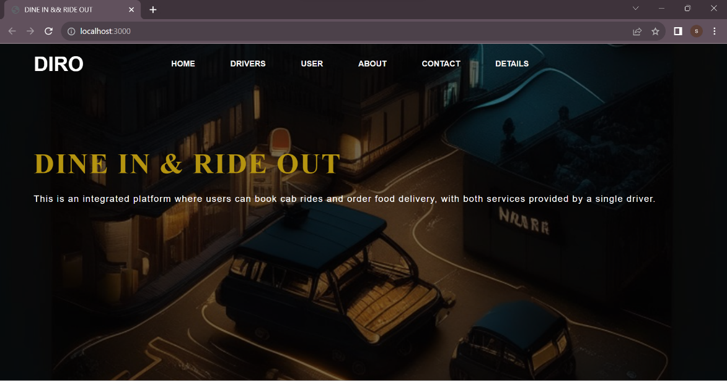

Fig 5.1: Home page of Dine in and ride out page

This is the home page For Dine IN & Ride Out. This main page of the website is accessed through the specified portal number in the web browser. This page mainly consists of a brief Description of our web-site i.e.; the Dine IN & Ride Out importance’s and details. This page has got several tabs named as Home, Client, User, About, Details, Contact Us. If we select any tags the further gets Display in the website.

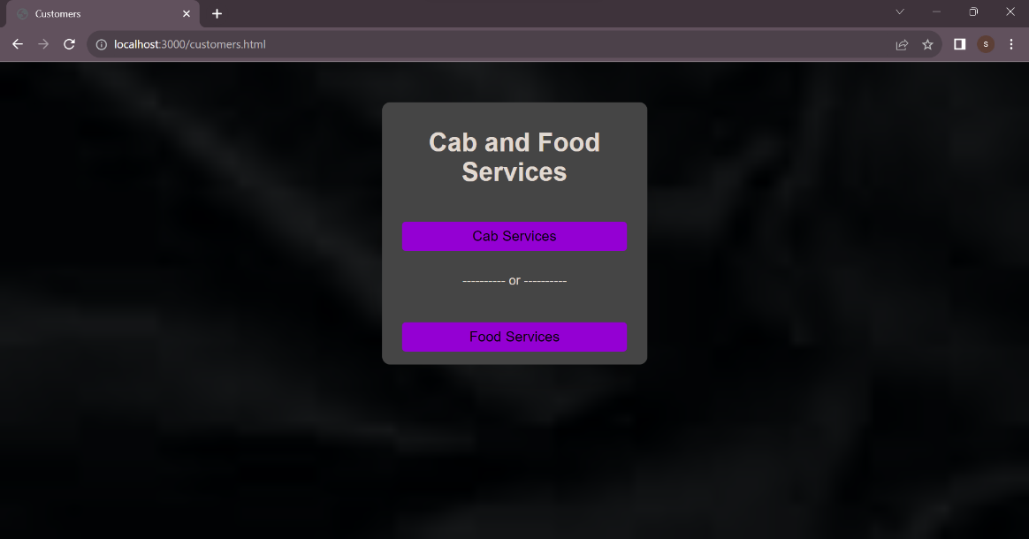

Fig 5.2: Service Selection page

The "Customer’s" page is the next page if the User anchor tag is clicked in main page and the page suggests the customers to select the type of services they want to go through. The page displays two options: "CAB SERVICES" and "FOOD SERVICES." Customers can choose one of the services by selecting the appropriate option. Depending on the customer's selection, the system will redirect them to the respective login page for cab services or food services.

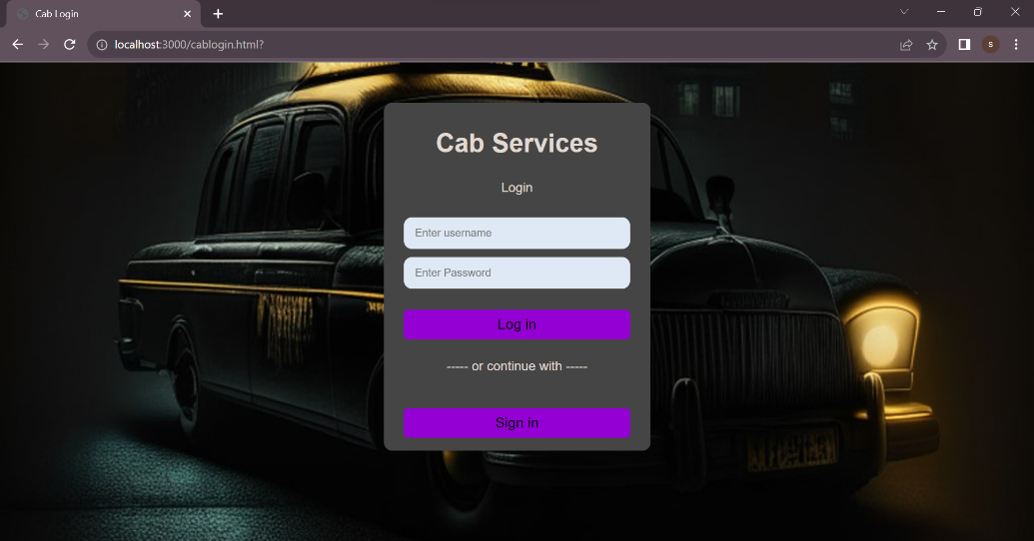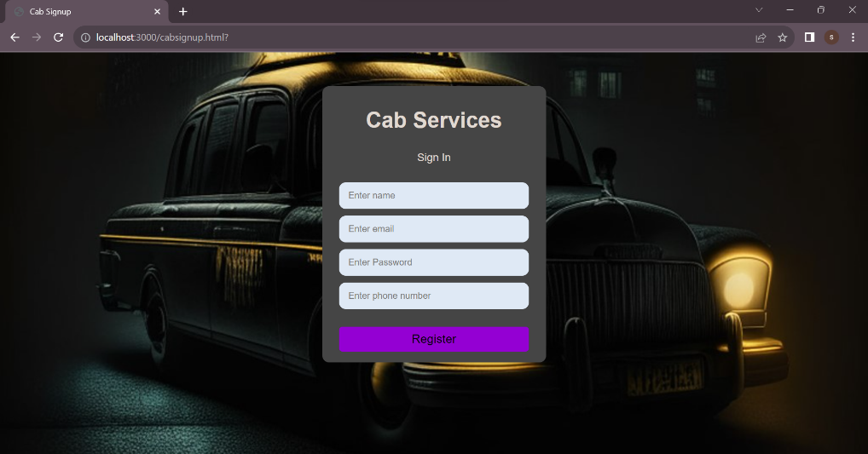

Fig 5.3: Cab Login and Sign-up pages.

If the CAB SERVICES is clicked or selected at customers page the "Cab" functionality related pages will be open for booking the cabs for the user. It provides a dedicated login page for users to book cab if he/she already as account if not by clicking on signup the user can create an account on his/her name which will be handled through Post Response to the server. If account is Registered it will successfully redirect to next page.

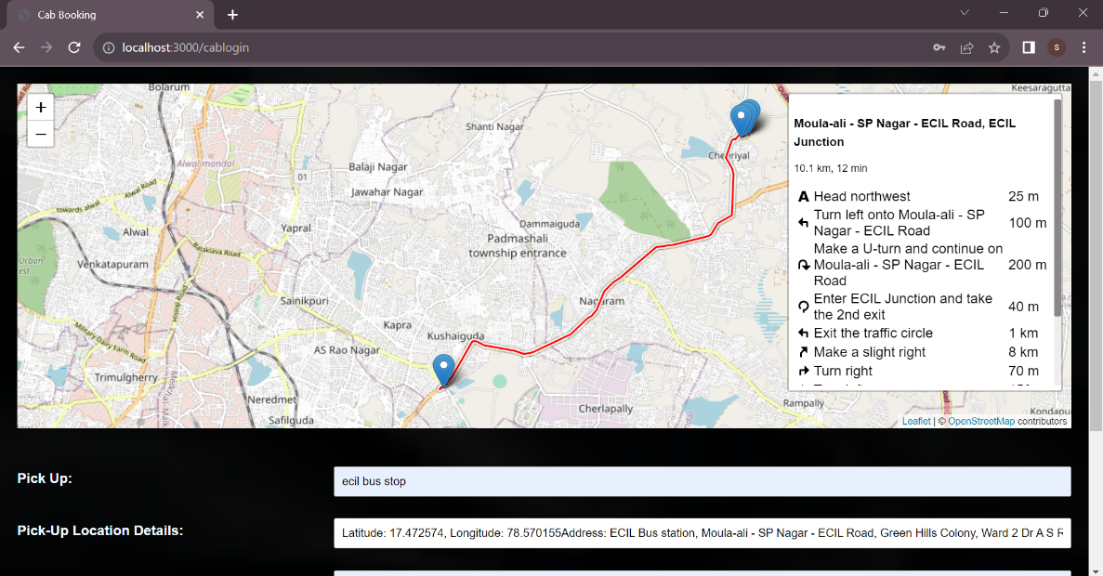

Fig 5.4: Pickup and Dropoff locations selecting page.

The Cab Map Page serves as the interface for users to input their pick-up and drop-off locations to book a cab. The page calculates and displays the distance and route based on the provided locations. When the user clicks the "Submit" button, the locations are stored in the database, and the distance information is redirected to the next page, possibly for cab booking. The "Clear" button allows users to reset the pick-up and drop-off locations if they need to make changes or start over.

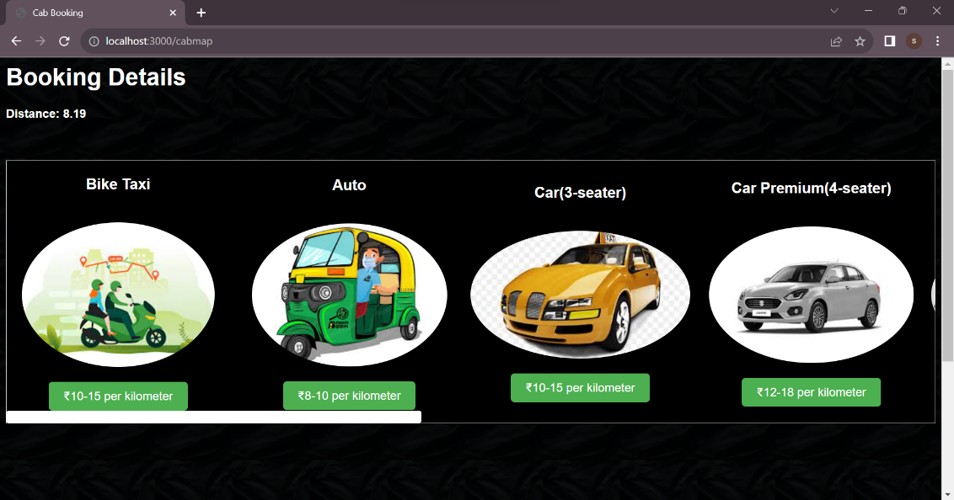

Fig 5.5: Cab type selection page.

The Cab Booking process involves the user selecting a cab type and providing the distance for which they want to book the cab. After the user submits the information, the system calculates the price for the booking. If the user confirms the booking by clicking the "Submit" button, the cab booking is confirmed, and the cab will be dispatched. In case of any issue or if the user clicks the "Cancel" button again, they are redirected back to the Cab map page to make necessary changes or proceed with another booking.

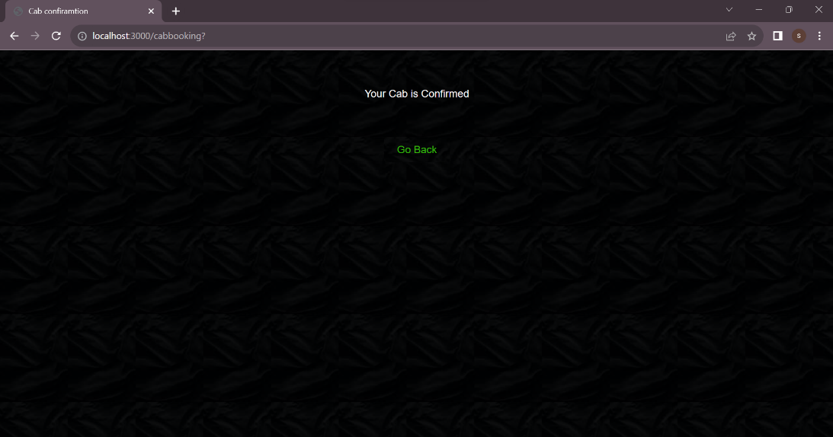

Fig 5.6: Cab Confirmation page.

The Cab is booked for the provided pick up and drop off locations and redirect to the customer’s page.

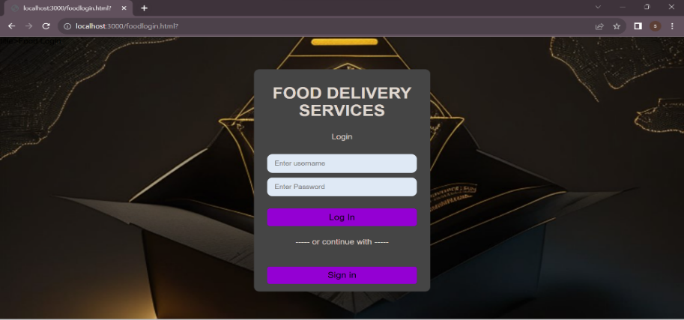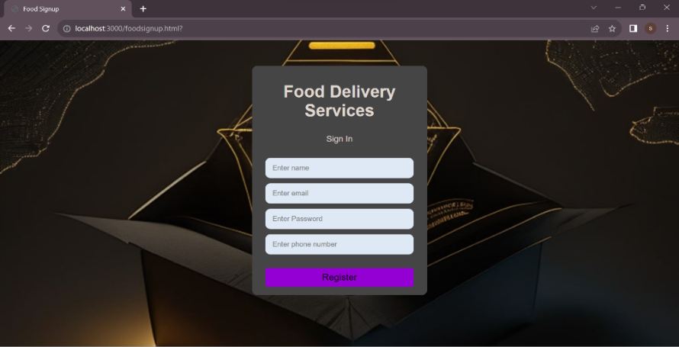

Fig 5.7: Food Login and Sign-up pages.

If the FOOD SERVICES is clicked at customers page the "food" functionality is responsible for managing the food delivery services in the system. It provides a dedicated login page for users to food services if he/she already as account if not by clicking on signup the user can create an account on his/her name which will be handled through Get Post Response Request from server. If account is Registered it will successfully redirect to next page.

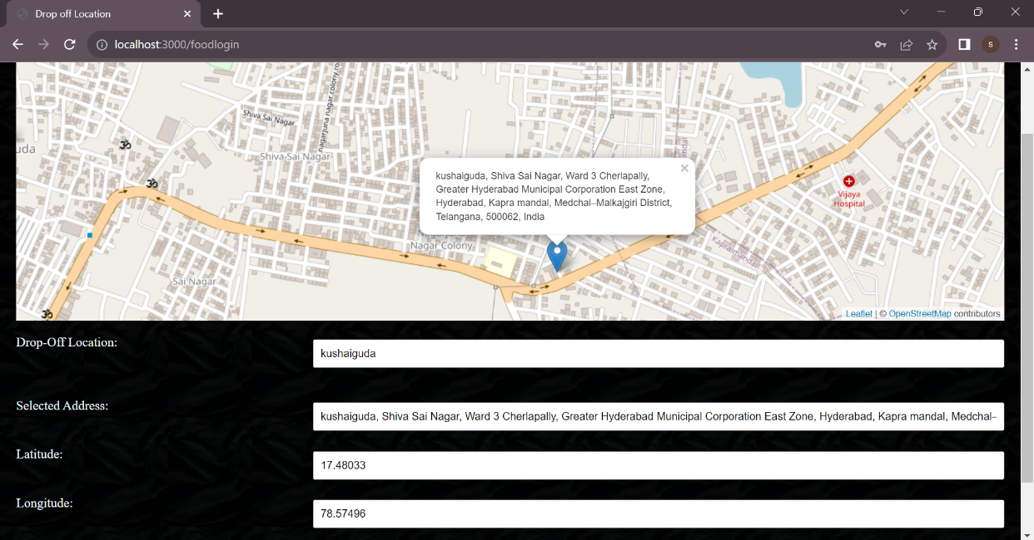

Fig 5.8: Dropoff location for food delivery.

The "Food Drop-Off" page allows users to specify their drop-off location for food delivery services. The drop-off location information is stored in the database, which helps in managing food deliveries efficiently. After the user enters the drop-off location and submits the information, they are directed to the "Restaurants Page" to explore available restaurants and place food orders. The "Clear" button allows users to reset the drop-off location input field, enabling them to change or clear the location if needed.

The "Type of Food" page provides a selection of food items based on the user's chosen type of food. After the user selects the food items they wish to order, they proceed to confirm the order by clicking the "Submit" button. The "Food Order Confirmation" means that the user's selected food items are officially registered as their order and are ready for processing.

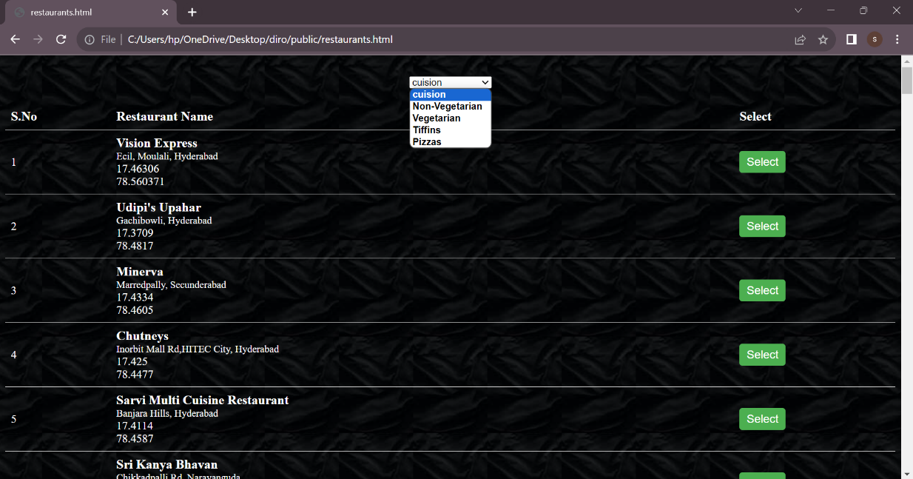

Fig 5.9: Restaurants selection page.

The "Restaurants" page provides a user-friendly way for users to choose the type of food they are interested in, such as vegetarian, non-vegetarian, tiffin, or pizzas. After selecting a type of food, the system displays a list of relevant restaurants offering that specific type of food. Once the user finds their desired food restaurants, they can confirm the restaurant order by clicking the "Submit" button. The confirmation process redirects to Type of Food to select based on food type.

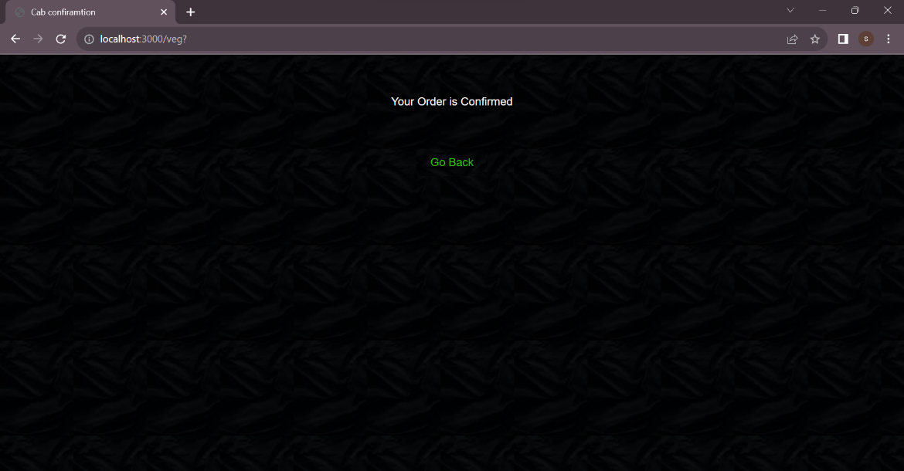

Fig 5.10: Food Confirmation page.

The Food is booked form the provided restaurants and gets drop the order at given drop off location and redirect to the customers page.

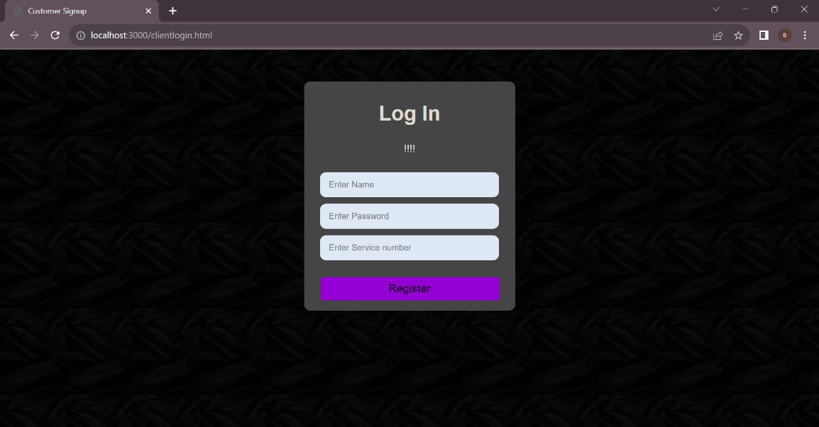

Fig 5.11: Driver Login page.

The "Driver Login" process is a fundamental security measure to protect accounts and ensure access to appropriate services. It is accessed for the driver only.

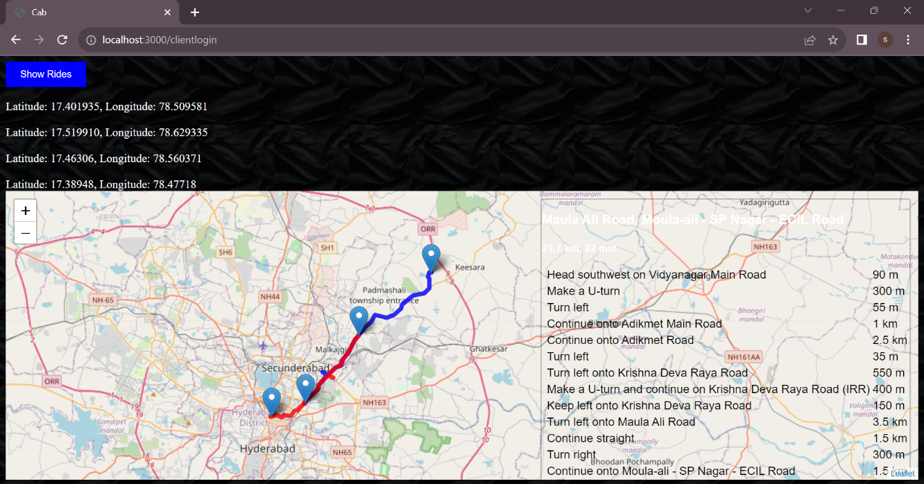

Fig 5.12: Map view if there is possibility for food and cab.

* Red Line (Food Delivery Route): This line would be used to indicate the path taken by the delivery driver to deliver food from a restaurant to a customer's location.
* Blue Line (Cab Route): The blue line, on the other hand, would represent the path taken by a cab or ride-sharing service to transport passengers from one location to another.

These color-coded lines make it easy for users to distinguish between different types of services or routes on a map, making navigation and understanding the map much more straightforward.

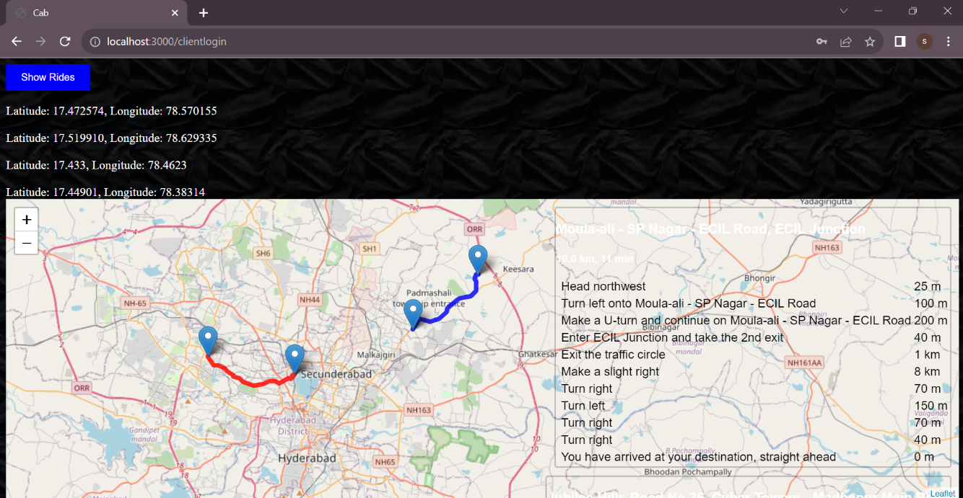

Fig 5.13: Map view if there is not possibility for food and cab.

The "Client Fetch Routes" process provides a visual representation of pick-up and drop-off locations for both cab and food services. If multiple routes are available and driving is possible between the locations, the client can confirm the order for both cab and food services. If there are no alternative routes or it is not possible to drive, the client can proceed with only cab rides and exclude food delivery.

**6. FUTURE SCOPE**

* Integrating with groceries delivery apps for an all-in-one available platform.
* Integrating with courier delivery apps for an all-in-one available platform.
* Integrating with apps for an all-in-one available platform.
* Integration with AI technology for personalized recommendations to customers

**7. CONCLUSION**

The integration of cab rides and food delivery on a single platform represents an exciting development in the pursuit of enhanced convenience for modern consumers. By merging these essential services, businesses can streamline operations, optimize resources, and deliver a seamless user experience.

The convergence not only benefits customers by saving time and effort but also presents significant growth opportunities for service providers in an increasingly competitive market. As this trend continues to evolve, we can expect further innovations and integrations that redefine convenience in our daily lives.

In conclusion, the convergence of cab rides and food delivery on a single platform represents a game-changing development that revolutionizes convenience for modern consumers. By bringing together these essential services, businesses can optimize their operations, utilize resources efficiently, and deliver a seamless user experience. This integration not only benefits customers by saving time and effort but also opens up significant growth opportunities for service providers in a competitive market.

The unified platform offers enhanced convenience for users, eliminating the need to switch between multiple apps or websites to fulfil their transportation and food needs. Customers can seamlessly access both services from a single location, leading to a cohesive and user-friendly experience.

**8. REFERENCES**

* www.wikipedia.org
* www.openstreetmap.org
* www.theleaflet.com
* www.w3schools.com
* [www.simplelearn.com](http://www.simplelearn.com)
* [www.oracle.com](http://www.oracle.com)
* www.openai.com